CHANGES HISTORY
PIC | Date | Remarks
BJM.MR | 2018.05.04 | Created
Ghaida | 2018.05.04

TOC
- Parameter Securities Asset Category
- Parameter Securities Status
- Parameter Securities Coupon Frequency
- Parameter Securities Coupon Calculation
- Parameter Securities Corporate Action Type
- Parameter Securities Instrument Type
- Parameter Securities Days In Year
- Parameter Securities Fitax Method
- Parameter Securities Days In Month
- Parameter Securities Inventory Method
- Parameter Securities Company Type
- Parameter Securities Intrument Type Sub
- Parameter Securities Cost Method
- Parameter Securities Benchmark Calculation
- Parameter Securities Benchmark Type
- Parameter Securities Index Type
- Parameter System User Status

Diagram ENTITY RELATIONSHIP

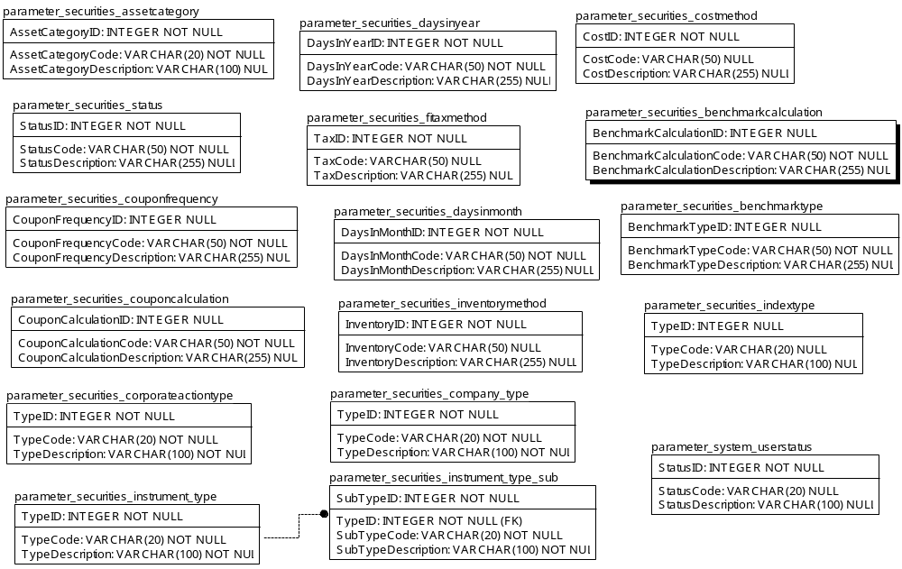

TABLE RELATIONSHIP
No | Table 1 | Table 2 | Type (1:1; 1:N; M:N) | Description
 | Parameter_securities_instrument_type | Parameter_securities_instrument_type_sub | M:N

Name |  | parameter_securities_assetcategory
Objective
No | Column |  | Type | Rule  (PK, FK, Key, NN, Unik, Index) | Description
1. | AssetCategoryID |  | Integer | NN
2. | AssetCategoryCode |  | Varchar(20) | NN
3. | AssetCategoryDescription |  | Varchar(100) | Null

SAMPLE DATA
No | Column | Sample 1 | Sample 2 | Sample 3 | Sample 4
1. | AssetCategoryID | 1 | 2 | 3 | 4
2. | AssetCategoryCode | FVTPL | AFS | HTM | LOAN
3. | AssetCategoryDescription | Fair value through profit/loss | Available for sale | Hold to maturity | Loan

Name |  | parameter_securities_status
Objective
No | Column |  | Type | Rule  (PK, FK, Key, NN, Unik, Index) | Description
1. | StatusID |  | Integer | NN
2. | StatusCode |  | Varchar(50) | NN
3. | StatusDescription |  | Varchar(255) | Null

SAMPLE DATA
No | Column | Sample 1 | Sample 2 | Sample 3 | Sample 4
1. | StatusID | 1 | 2 | 3 | 4
2. | StatusCode | PENDING | ACTIVE | SUSPEND | MATURE
3. | StatusDescription | PENDING | ACTIVE | SUSPEND | MATURE

Name |  | parameter_securities_couponfrequency
Objective
No | Column |  | Type | Rule  (PK, FK, Key, NN, Unik, Index) | Description
1. | CouponFrequencyID |  | Integer | NN
2. | CouponFrequencyCode |  | Varchar(50) | NN
3. | CouponFrequencyDescription |  | Varchar(255) | Null

SAMPLE DATA
No | Column | Sample 1 | Sample 2 | Sample 3 | Sample 4
1. | CouponFrequencyID | 1 | 2 | 3
2. | CouponFrequencyCode | 2 | 4 | 12
3. | CouponFrequencyDescription | Semi annually | Quarterly | Monthly

Name |  | parameter_securities_couponcalculation
Objective
No | Column |  | Type | Rule  (PK, FK, Key, NN, Unik, Index) | Description
1. | CouponCalculationID |  | Integer | NN
2. | CouponCalculationCode |  | Varchar(50) | NN
3. | CouponCalculationDescription |  | Varchar(255) | Null

SAMPLE DATA
No | Column | Sample 1 | Sample 2 | Sample 3 | Sample 4
1. | CouponCalculationID | 1 | 2
2. | CouponCalculationCode | A | C
3. | CouponCalculationDescription | Annual Based | Coupon Based

Name |  | parameter_securities_corporateactiontype
Objective
No | Column |  | Type | Rule  (PK, FK, Key, NN, Unik, Index) | Description
1. | TypeID |  | Integer | NN
2. | TypeCode |  | Varchar(20) | NN
3. | TypeDescription |  | Varchar(100) | NN

SAMPLE DATA
No | Column | Sample 1 | Sample 2 | Sample 3 | Sample 4
1. | TypeID | 1 | 2 | 3 | 4
2. | TypeCode | EQ STOCK SPLIT | EQ STOCK REVERSE | EQ DIVIDEND CASH | EQ DIVIDEND SHARE
3. | TypeDescription

Name |  | parameter_securities_instrument_type
Objective
No | Column |  | Type | Rule  (PK, FK, Key, NN, Unik, Index) | Description
1. | TypeID |  | Integer | NN
2. | TypeCode |  | Varchar(20) | NN
3. | TypeDescription |  | Varchar(100) | NN

SAMPLE DATA
No | Column | Sample 1 | Sample 2 | Sample 3 | Sample 4
1. | TypeID | 1 | 2 | 3 | 4
2. | TypeCode | EQ | FI | FUND | ASSET
3. | TypeDescription | EQUITY | FIXED INCOME | MUTUAL FUND | PHYSICAL ASSET

Name |  | parameter_securities_daysinyear
Objective
No | Column |  | Type | Rule  (PK, FK, Key, NN, Unik, Index) | Description
1. | DaysInYearID |  | Integer | NN
2. | DaysInYearCode |  | Varchar(50) | NN
3. | DaysInYearDescription |  | Varchar(255) | Null

SAMPLE DATA
No | Column | Sample 1 | Sample 2 | Sample 3 | Sample 4
1. | DaysInYearID | 1 | 2 | 3 | 4
2. | DaysInYearCode | A | 360 | 365 | 366
3. | DaysInYearDescription | Actual days | 360 days | 365 days | 366 days

Name |  | parameter_securities_fitaxmethod
Objective
No | Column |  | Type | Rule  (PK, FK, Key, NN, Unik, Index) | Description
1. | TaxID |  | Integer | NN
2. | TaxCode |  | Varchar(50) | Null
3. | TaxDescription |  | Varchar(255) | Null

SAMPLE DATA
No | Column | Sample 1 | Sample 2 | Sample 3 | Sample 4
1. | TaxID | 1 | 2
2. | TaxCode | NETTING | NON NETTING
3. | TaxDescription | Tax calculate from netting coupon & capital loss if exists | Tax calculate separatelly from coupon and capital gain/loss

Name |  | parameter_securities_daysinmonth
Objective
No | Column |  | Type | Rule  (PK, FK, Key, NN, Unik, Index) | Description
1. | DaysInMonthID |  | Integer | NN
2. | DaysInMonthCode |  | Varchar(50) | Null
3. | DaysInMonthDescription |  | Varchar(255) | Null

SAMPLE DATA
No | Column | Sample 1 | Sample 2 | Sample 3 | Sample 4
1. | DaysInMonthID | 1 | 2 | 3 | 4
2. | DaysInMonthCode | A | 30 | 30E | 30U
3. | DaysInMonthDescription | Actual days | 30 days | 30 days eurobond basis | 30 days US corporate bond basis

Name |  | parameter_securities_inventorymethod
Objective
No | Column |  | Type | Rule  (PK, FK, Key, NN, Unik, Index) | Description
1. | InventroyID |  | Integer | NN
2. | InventroyCode |  | Varchar(50) | Null
3. | InventroyDescription |  | Varchar(255) | Null

SAMPLE DATA
No | Column | Sample 1 | Sample 2 | Sample 3 | Sample 4
1. | InventroyID | 1 | 2
2. | InventroyCode | FIFO | AVERAGE
3. | InventroyDescription | First in first out | Average

Name |  | parameter_securities_company_type
Objective
No | Column |  | Type | Rule  (PK, FK, Key, NN, Unik, Index) | Description
1. | TypeID |  | Integer | NN
2. | TypeCode |  | Varchar(20) | NN
3. | TypeDescription |  | Varchar(100) | NN

SAMPLE DATA
No | Column | Sample 1 | Sample 2 | Sample 3 | Sample 4
1. | TypeID | 1 | 2 | 3 | 4
2. | TypeCode | CORP | BANK | IM | GOVT
3. | TypeDescription | Corporate | Bank | Investment/fund manager | Government

Name |  | parameter_securities_instrument_type_sub
Objective
No | Column |  | Type | Rule  (PK, FK, Key, NN, Unik, Index) | Description
1. | SubTypeID |  | Integer | NN
2. | TypeID |  | Integer | FK
3. | SubTypeCode |  | Varchar(20) | NN
4. | SubTypeDescription |  | Varchar(100) | NN

SAMPLE DATA
No | Column | Sample 1 | Sample 2 | Sample 3 | Sample 4
1. | SubTypeID | 1 | 2 | 3 | 4
2. | TypeID | 1 | 1 | 1 | 1
3. | SubTypeCode | OS | PS | WARRANT | RIGHT
4. | SubTypeDescription | Ordinary Share | Preferend Share | Warrant | Right

Name |  | parameter_securities_costmethod
Objective
No | Column |  | Type | Rule  (PK, FK, Key, NN, Unik, Index) | Description
1. | CostID |  | Integer | NN
2. | CostCode |  | Varchar(50) | Null
3. | CostDescription |  | Varchar(100) | Null

SAMPLE DATA
No | Column | Sample 1 | Sample 2 | Sample 3 | Sample 4
1. | CostID | 1 | 2
2. | CostCode | CAPITALIZE BASED | EXPENSE BASED
3. | CostDescription | CAPITALIZE BASED | EXPENSE BASED

Name |  | parameter_securities_benchmarkcalculation
Objective
No | Column |  | Type | Rule  (PK, FK, Key, NN, Unik, Index) | Description
1. | BenchmarkCalculationID |  | Integer | Null
2. | BenchmarkCalculationCode |  | Varchar(50) | NN
3. | BenchmarkCalculationDescription |  | Varchar(255) | Null

SAMPLE DATA
No | Column | Sample 1 | Sample 2 | Sample 3 | Sample 4
1. | BenchmarkCalculationID | 1 | 2
2. | BenchmarkCalculationCode | SIMPLE | COMPOUNDED
3. | BenchmarkCalculationDescription | Simple interest rate | Compounded interest rate

Name |  | parameter_securities_benchmarktype
Objective
No | Column |  | Type | Rule  (PK, FK, Key, NN, Unik, Index) | Description
1. | BenchmarkTypeID |  | Integer | Null
2. | BenchmarkTypeCode |  | Varchar(50) | NN
3. | BenchmarkTypenDescription |  | Varchar(255) | Null

SAMPLE DATA
No | Column | Sample 1 | Sample 2 | Sample 3 | Sample 4
1. | BenchmarkTypeID | 1 | 2
2. | BenchmarkTypeCode | VALUE | RATE
3. | BenchmarkTypenDescription | Value basis | Rate (%) basis

Name |  | parameter_securities_indextype
Objective
No | Column |  | Type | Rule  (PK, FK, Key, NN, Unik, Index) | Description
1. | TypeID |  | Integer | Null
2. | TypeCode |  | Varchar(20) | Null
3. | TypeDescription |  | Varchar(100) | Null

SAMPLE DATA
No | Column | Sample 1 | Sample 2 | Sample 3 | Sample 4
1. | TypeID | 1 | 2
2. | TypeCode | MARKETCAP | WEIGHT
3. | TypeDescription | Market Capitalization | Weighting

Name |  | parameter_system_userstatus
Objective
No | Column |  | Type | Rule  (PK, FK, Key, NN, Unik, Index) | Description
1. | StatusID |  | Integer | NN
2. | StatusCode |  | Varchar(20) | Null
3. | StatusDescription |  | Varchar(100) | Null

SAMPLE DATA
No | Column | Sample 1 | Sample 2 | Sample 3 | Sample 4
1. | StatusID | 1 | 2 | 3 | 4
2. | StatusCode | ACTIVE | SUSPEND | CLOSE | MATURE
3. | StatusDescription |  |  |  | MATURE

